PAM Product Datasheet
Privileged Access Management:
A robust security solution that effectively manages and monitors privileged access to critical data, reducing security risks.
At a Glance:
Privileged Access Management (PAM) solution is designed to provide security by managing and monitoring privileged access to vital systems, applications, and data. By implementing advanced access controls and comprehensive oversight, our PAM solution mitigates risks associated with privileged accounts, ensuring that your organization remains secure and compliant.
Product Overview:
Ensuring the protection of sensitive data is of utmost importance in today's digital era. Our Privileged Access Management (PAM) solution delivers robust security by managing and monitoring privileged access to critical systems, applications, and data.
Key features include centralized access control with role-based access policies, automated workflows for efficient user management, and comprehensive session monitoring for audit trails. Multi-factor authentication (MFA) enhances security, while risk-based analytics detect and respond to potential threats.
Seamless integration with various IT environments, including on-premises and cloud ensures minimal disruption. Our PAM solution supports compliance with industry regulations through detailed reporting and monitoring capabilities.
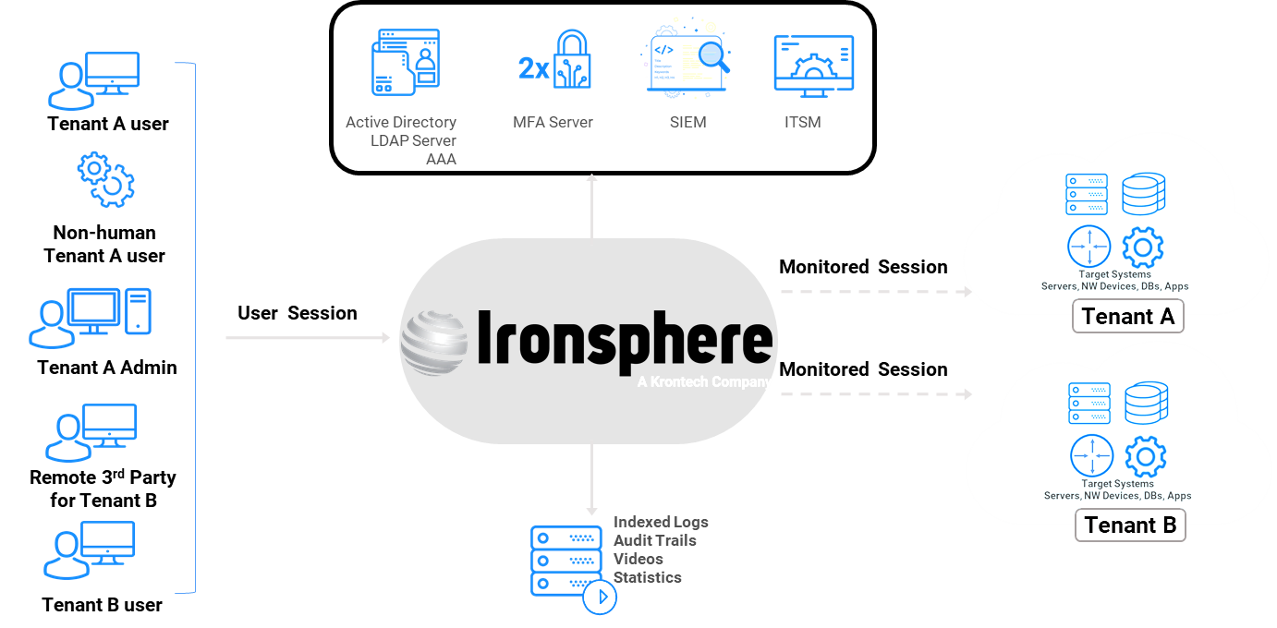


Key Benefits:
- Enhanced Security
- Risk Reduction
- Operational Efficiency
- Regulatory Compliance
- Scalability
- Comprehensive Monitoring
- Centralized Management

The Garaj Advantage:
- Local Support
- Managed Services
- Local Availability
- Zone Dedicated Account Manager
- Intrinsic Security
- Local Currency Billing
- Onshore Data Residency
- Uncapped Traffic Data

Use Cases:
- Sensitive data protection
- Insider Threat Mitigation
- Access Control
- Password Management

